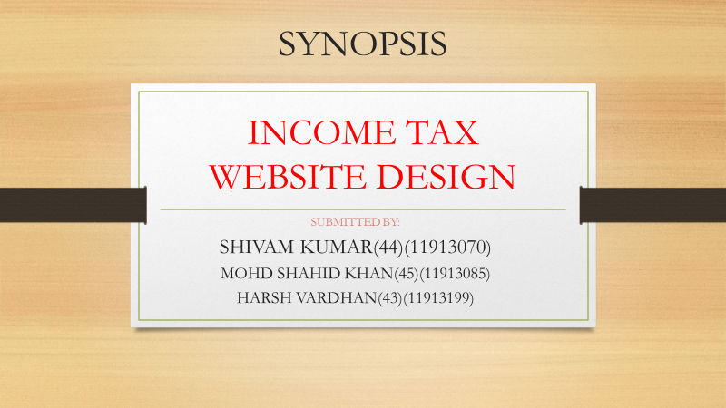

PROJECT DISCRIPTION

* After opening the website, on the front page you will get

the login option where you can login to the website using

your name and password.

* There is one more option of linking your pan card to

Aadhar card to your website which is to make your

account more secure.

* On the front page you will also get important news about

the stuffs related to income tax.

* After login to the website user can see and pay there

income taxes from here.

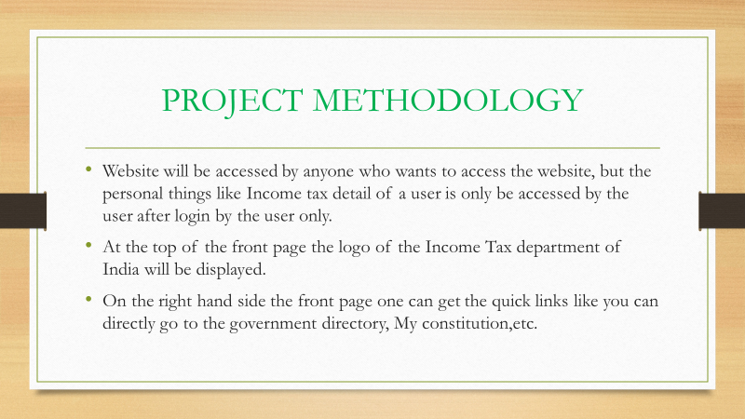

PROJECT USEFULLNESS

In this world of digitialization everything is in your phone or laptop so why not income tax.From this website you are only one click away from paying taxes from sitting at home.

THANK YOU.